WEB TECHNOLOGIES
Unit – I
One Mark Questions
- Define HTML?
- Write a code for making text area?
- Marquee tag has following attributes _______.
a) Behaviour b) direction c) position d) both (a) and (b)
- For largest level of heading which tag is used?
- What is Cascading Style Sheets?
- Explain the syntax of image tag?
- The language used to develop web page is _______.
- How to Open a Link in a new browser window/tab?
- What is the purpose of <frameset> tag?
- Which tag is used to make numbered list?
- Which tag is used to create drop-down list?
- Explain the syntax of Anchor tag?
- Which attribute is used to change the table border color?
- Which property is used to change the background color in CSS?
- Write a Javascript program to find biggest number among two numbers?
- What is a Definition List?
- What is the purpose of creating hyperlinks?
- Explain <br> and <hr> tag?
- What are the attributes that can be used with <table> tag?
- Write the html syntax for inserting a background image?
- ---------is also called client side scripting language?
- Write a Javascript program to display alert message “HI”?
- Write the uses of java script?
- How to declare variables in Javascript? Declare variable a and assign 10 to it?
- Server-side Applications vs. Client-side Applications?
- What is DHTML?
- Write a Javascript program to print “hello”?
- Write the syntax to define function in Javascript?
- Which tag is used to create italic text?
- Which tag is used to create superscript?

TEN Mark Questions

- What is meant by FORM? Create a HTML document to demonstrate Form Elements that includes Form, input-text, password, radio, checkbox, button, submit, reset, label, textarea, select, option, file upload.
- Write a HTML code for the following table?

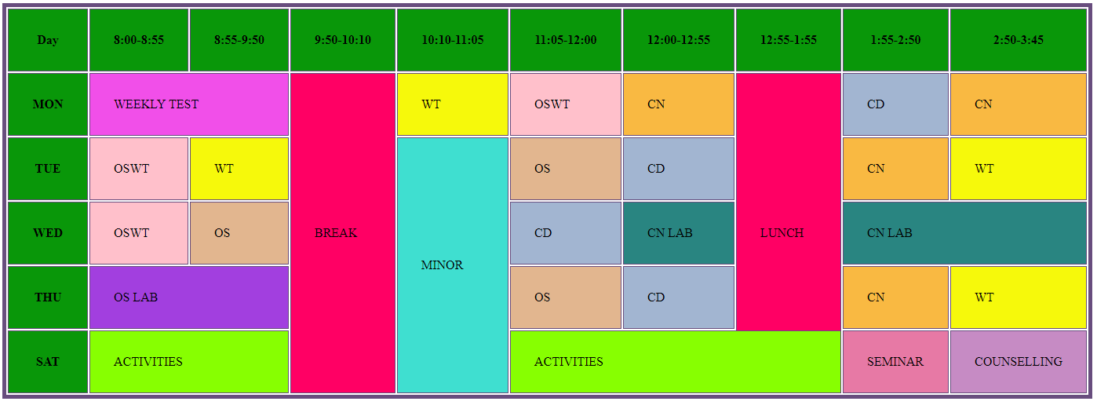

a) Explain about Lists with Example? (6M)
- Explain about Frames with Example? (4M)
- What is CSS? Explain the ways of including style information in a document.?
- Explain about Built-in objects in Javascript?
- Write a JavaScript program to display addition of two numbers when ADD button is pressed, display division when DIV button is pressed and display multiplication when MUL button is pressed and display subtraction when SUB button is pressed.
